十年高考真题分类汇编（2010-2019）英 语
专题27 图画式书面表达
(2010﹒北京)
假设你是红星中学高二(1)班的学生李华，利用上周末的时间帮助祖父母安排了去北戴河的旅行。请根据以下四幅图的先后顺序，写一篇英文周记，叙述你从准备到送行的全过程。
注意：1．周记的开头已为你写好。
2．词数不少于60。
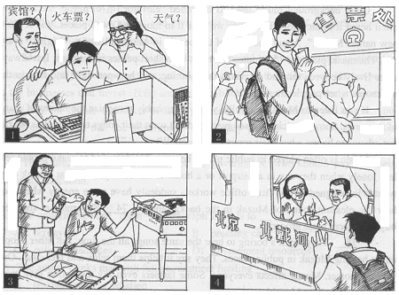
Last weekend, I helped my grandparents prepare their trip to Beidaihe.
基本分析：
1. 文体：周记。
2. 人称：I
3. 时态：一般过去时
4. 事件大意：我为爷爷奶奶准备出行＋我送行
5. 图片要素：
图一：查询信息（train ticket, weather, hotel）
图二：买票（buy ticket）
图三：准备行装（package）
图四：送行（see-off）
3. 图片关联：
图一、二、三都是并列关系，主题是旅游前的准备阶段，三幅图没有轻重之分，所占篇幅比例相当。图四是最后的送别阶段，文章末尾要有点睛之笔，可以是送别感受，对爷爷奶奶的祝福，也可以是自己的成长和收获。
4. 文章立意：今年的作文和90后的学生特点相联系，积极引导高中学生要培养独立性，增加实践能力，并要照顾体谅长辈。所以文章末尾的立意也可以往这方面考虑。
5. 参与范文（官方）：
Last weekend, I helped my grandparents their trip to Beidaihe. On Saturday morning, together with my grandparents, I searched the Internet for the train schedule, the weather in Beidaihe, and some hotel information. In the afternoon, I went to the train station and managed to buy two tickets for my grandparents although there was a long queue. After dinner, I packed into the suitcase the things my grandparents need, such as clothes, glasses, an umbrella, and a map. The next morning, I went to the station to see them off. Waving goodbye to them on the platform, I felt happy for them and wished them a safe journey.

(2012﹒北京)
情景作文（20分）
假设你是红星中学高三（1）班的学生李华，校报英文版正在开展“续写雷锋日记”活动。请根据以下四幅图的先后顺序，将你所做的一件好事以日记形式记述下来，向校报投稿。
注意：1.日记的开头已为你写好。
2.词数不少于60。

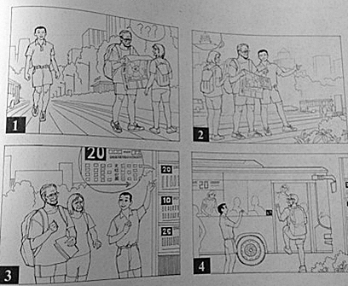
Saturday，June2 Fine
This morning
【参考范文】
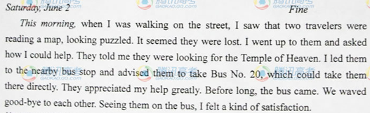
(2012﹒陕西)
书面表达 (满分30分)
假定你是李华。下面的图画描述了教师节那天你们班组织的一次活动，请根据写作要点并参考图画内容，为校刊“英语角”版面写一篇短文。
写作要点：
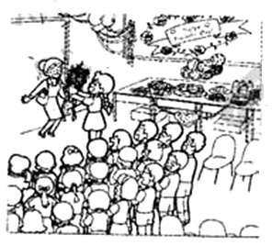
1．活动的策划； 2．教室的布置；
3．活动的内容； 4．你的感想。
注意：
1．短文词数不少于100；
2．开头部分已写好，不计入总词数；
3．可根据情况增减细节，详略得当；
4．不能使用真实姓名和学校名称。
Ms. Li, our English teacher, must have found it strange on Teachers’ Day; she did not receive a single greeting card from us students. She would have never thought a complete surprise was waiting for her.
【参考范文】
Ms. Li, our English teacher, must have found it strange on Teachers’ Day; she did not receive a single greeting card from us students. She would have never thought a complete surprise was waiting for her.
As Teachers’ Day was approaching, our class decided to hold a party to celebrate the important day for a change this year. On the afternoon of September 10，some of us decorated our classroom with paper flowers and balloons, and others went to buy cakes, drinks and fruits. The blackboard was decorated with beautiful words, which read “Happy Teachers’ Day!”
Entering the classroom, Ms. Li was surprised to find we were standing in line, clapping hands and saying loudly “Happy Teachers’ Day!” Wang Hua, our monitor, presented her with the prepared flowers. Some of the girls sang songs for Ms. Li, and three boys showed their Gongfu talent. Before we left, we enjoyed a new English song by Ms. Li.
Ms. Li spent a wonderful time with us, but we know that we cannot thank her enough for all her hard work and guidance.

(2012﹒福建)
假定你是某中学生英语报的小记者；以下漫画内容是你的所见所闻,谙根据要求写一篇英语短文投稿。
内容要求：
1.描述漫画内容； 2.发表个人感想。
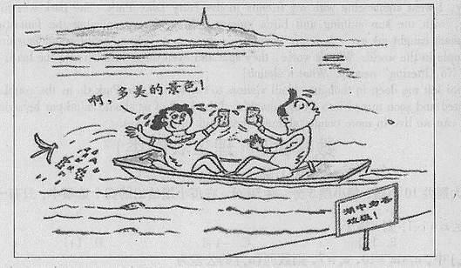
注意：
1. 短文标题与开头已给出,不计入总词数；
2. 考生可适当发挥，使文章内容充实、连贯
3. 词数120左右;
4. 文中不能出现考生的具体信息。
参考词汇:告示牌sign

Mind Your Behavior in Public Places
Last Sunday, I went sightseeing with my friends in the Fairy Lake Park.

【参考范文】
参考范文 Mind Your Behavior in Public Places
Last Sunday, I went sightseeing with my friends in the Fairy Lake Park. The park was full of freshness and beauty of spring, with the sun shining and birds singing. When I was enjoying the fantastic scenery around, something unpleasant caught my eye. A young couple in a boat were eating, talking and laughing loudly as if they were the only people in the world. What's worse, they spat and even threw rubbish into the lake, totally ignoring the noticeable sign "No Littering" nearby. What a shame!
Such behavior left me deep in thought. If all visitors to the Fairy Lake Park do as the couple did, the lake will be severely polluted and soon turned into a huge dustbin. I think all of us should mind our behavior in public places. Only in this way can we live in more comfortable and beautiful surroundings.

(2013﹒福建)
书面表达(满分25分）
孩子的成长和教育是社会热议的话题，现今父母包揽一切、孩子过度依赖等现象十分严重。请阅读下面 的漫画，按要求用英文写一篇短文。
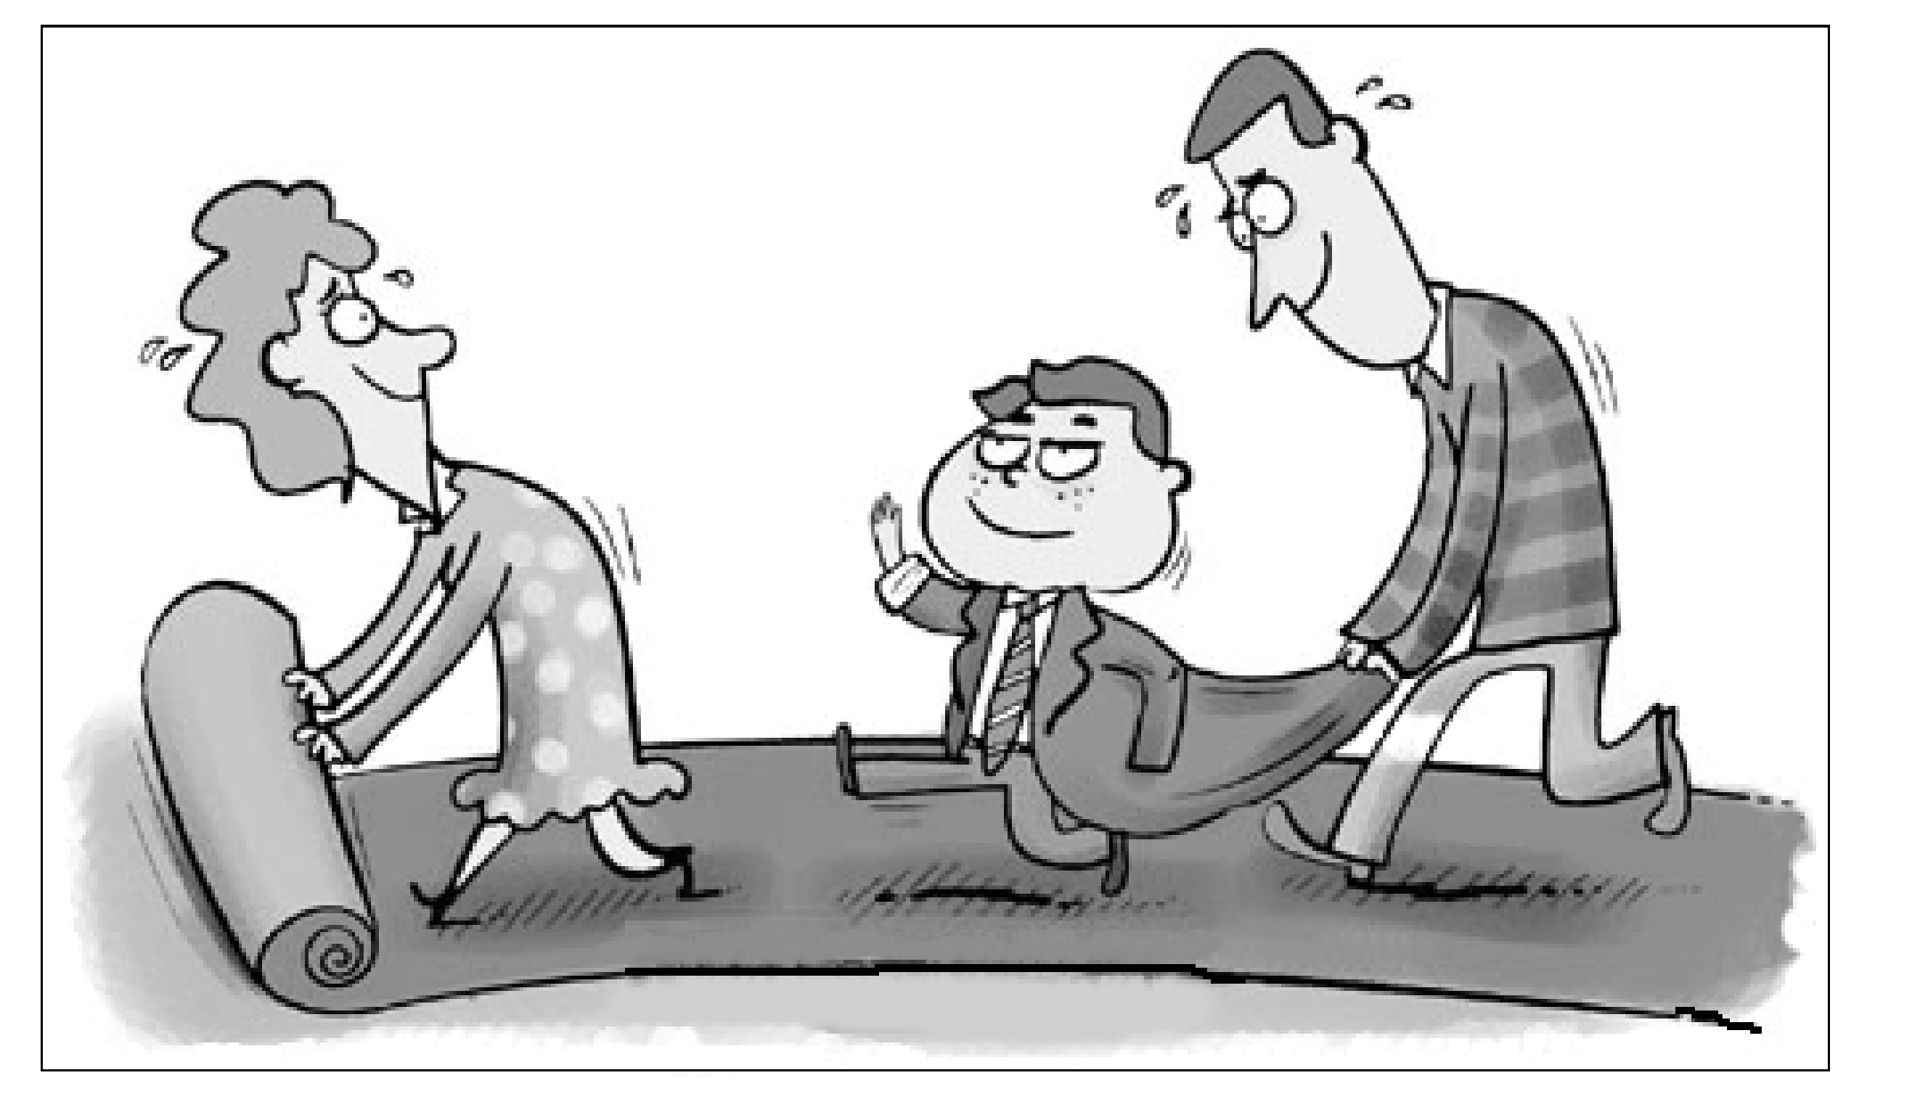

内容要求：
1.描述漫画内容；
2. 分析漫画所揭示的问题；
3. 提出你的看法。
注意：
1.短文开头已给出，不计入总词数；
2.考生可适当发挥，使文章内容充实、连贯；
3.词数120左右;
4. 文中不能出现考生的具体信息。
参考词汇:pave the way

From the picture, we can see a family of three walking on a long red carpet.
_______________________________

One possible version:
From the picture we can see a family of three walking on a long red carpet. The son , well dressed, waves proudly in the middle while the father behind bends forward to hold the jacket and the mother in front rolls out the carpet, sweating.
It shows a common phenomenon nowadays that children are the focus of families, shouldering the hope of their parents. Parents arrange everything for their children and spare no effort to pave the way for their success. As a consequence, children become so reliant on their parents that they have no independent thought or creative ideas.
Such a situation is of great concern. In my opinion, overprotection and too much care are extremely bad for children’s development. Instead of doing everything for them, parents should encourage their children to overcome difficulties and inspire them to develop by themselves. Only in this way can they grow up to be independent and become truly successful.
(2013﹒北京)
书面表达（共两节，15 分）
第一节 情景作文（20 分）
假设你是红星中学高三（1）班的学生李华，请按照以下四幅图的先后顺序，用英文写一篇周记。记述爸爸出 差期间，妈妈生病，你照顾她的过程。
注意： 1. 周记的开头已经为你写好。
2. 词数不少于 60.
Last Monday,

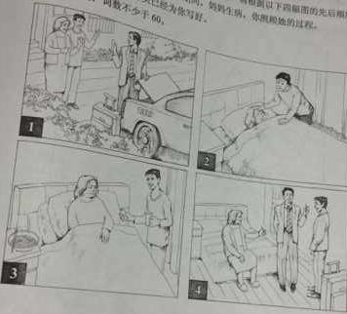

【参考范文】1
Last Monday, my father said goodbye to my mother and me and went on a business trip. He would be away for three days. Just the next morning I found my mother wasn’t feeling well. She had a cold. I immediately went to get her some medicine and then prepared some noodles for her. With my special care, my mother recovered quickly. When my father came back home, my mother told him what had happened. He praised me for what I had done.
I feel very happy that I have done something for my mother.
【参考范文】2
Last Monday, my father would be on a business trip for five days. Having gotten my promise of being great at home and taking care of my mother, he rest assured and put his luggage into the trunk of his car. Seeing my father’s driving away, my mother and I waved our hands and said goodbye to him. For a moment, I began to miss my father, wishing that he would be safe and well the next days.
I thought everything would go well, as this was not the first time that my father had been away for several days. Yet, unfortunately, my mother caught a cold the next morning. Looking at her pale face, I experienced high levels of anxiety. However, I told myself that I had to calm down and look after my mum, as I promised to my dad. The moment I got my mum to sleep, I put cold towel on her forehead, found pills in the medicine box, and made some noodles for her. Luckily, she waked up and felt better, after taking the pills and the noodles. That her fever was gone relieved and satisfied me a lot.
In the next four days, I was taking her body temperature twice a day, ensuring that she was completely well. To our delight, my dad went back home safely and healthily on Saturday. On hearing what I had done to my mum, he, as well as my mum, beamed at me and gave me a big thumb. Hearing their praises and seeing bright smiles on their faces, I really felt overjoyed and thrilled. Conceivably, taking care of my parents was, indeed and definitely, my mission and obligation.

(2013﹒江苏)
书面表达
请根据你对以下两幅图的理解, 以“Actions Speak Louder than Words”为题, 用英语写一篇作文。
参考词汇: banner (横幅)
stump (树桩)
你的作文应包括以下内容:
1. 简要描述两幅图的内容;
2. 概述你对两幅图中不同做法的理解;
3. 举例说明两幅图对你的启示。
注意:
1. 可参照图片适当发挥;
2. 作文词数150 左右;
3. 作文中不得提及有关考生个人身份的任何信息,如校名、人名等。

Actions Speak Louder than Words

【参考范文】
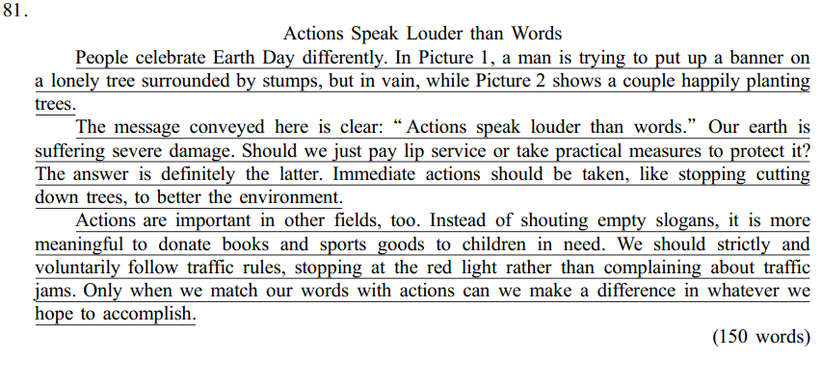
(2014﹒新课标全国卷Ⅰ)
假定你是李华，计划暑假期间去英国学习英语，为期六周。下面的广告引起了你的注意，请给该校写封信，询问有关情况(箭头所指内容)。
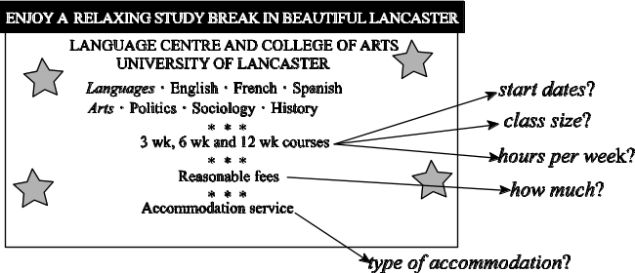
注意：1.词数100左右；
2．可以适当增加细节，以使行文连贯。
参考词汇：住宿 accommodation
【思路点拨】 本文是一篇书信应用文。文章内容是李华计划暑假期间去英国学习英语，看到广告后感觉广告里有一些问题没说清楚，想要给校方写信咨询有关事项。考生要注意信的格式，还要注意时态的选择，即以一般现在时为主，兼有将来时，人称用第一人称。注意恰当地使用一些连词，使文章自然、流畅，还可以使用一些高级句型和词汇来提高作文档次。
【参考范文】
Dear Sir/Madam，
I am a student in China and I plan to go to Britain to attend a summer school during the vacation.I've seen your ad，and I'd like to know something more about your sixweek English course.First，when will the course start and how many class hours are there per week？Besides，I wish there would not be too many students in a class.I'd also like to know how much I have to pay for the course and whether accommodation is included.Would there be host family or university dormitory?
I am looking forward to your early reply.
Yours faithfully，
Li Hua
(2014﹒辽宁)
假定你是学生会主席李华。学校将举办一次以“校园生活·创意无限(Innovations on Campus)”为主题的创意作品展评活动。请你根据以下图示，以短文形式用英语写一份书面通知。
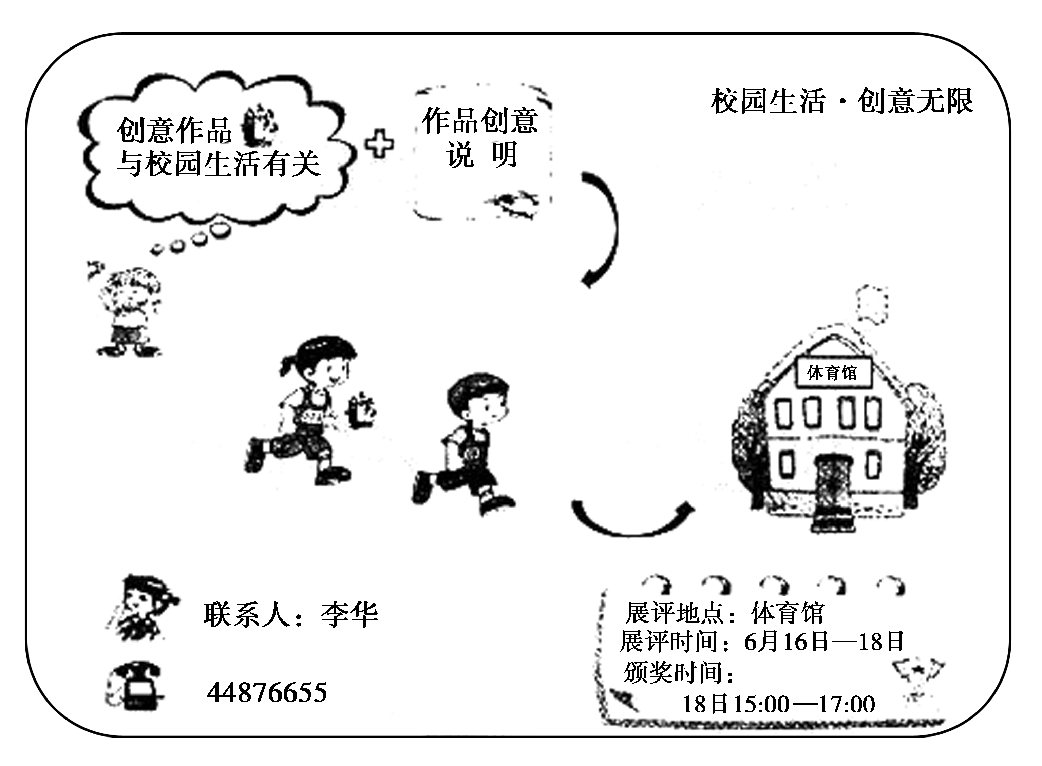
注意：1.词数100左右；
2．可以适当发挥，以使行文连贯；
3．开头及结尾已为你写好，不计入总词数。
参考词汇：校园campus 创意作品innovation 颁奖prizegiving
【思路点拨】
本文采取以图画为载体的方式实质考查提纲类写作，这与以前单纯提纲类写作相比难度有所增加，难点在于考生容易遗漏图画中所列要点。但此图画中文字描述较多，难度自然下降。由于体裁是通知，所以应较多使用灵活变化的短句，而少量使用长难句。图画中所列的要点较多，考生要注意点与点之间的合理有效结合。
本文要求考生充分发挥自己的想象力，灵活运用英语知识，采用不同的表达方式将各要点完整地表述出来，注意语言力求准确、简洁。根据图画的发展，按顺序安排好材料。同时应选用合适的连接词或过渡词，使文章具有一定的连贯性。考生必须认真检查是否有漏写情况，有无拼写错误及标点误用等。
One possible version
Notice
An exciting event “Innovations on Campus”is around the corner. Everyone of you is expected to be part of the event which encourages creative minds and gives full play to your DIY skills.
Note that your innovations must be school things. Along with your wonderful innovation, you need to hand in a report, explaining how the idea occurs to you and what materials you use.
All the collections will be on show from June 16 to 18 in the gym. Looking forward to the prizegiving ceremony? Sure! It'll be held from 15：00 to 17：00 on June 18. So don't miss the chance of being the winner. Your contribution will certainly make the event a huge success. For any questions, call Li Hua at 44876655.
Come on, everybody! It's your show time.
Student Union
(2015﹒上海)
Guided Writing
Directions: Write an English composition in 120–150 words according to the instructions given below in Chinese.
学校即将举办“读书节”，目前正广泛征集“读书节”宣传册图片。假设你是该校学生潘阳，你已找到以下三幅图片，决定给读书节组委会写一封信，推荐其中一幅，你的信须包括以下内容：
1. 简单描述你想推荐的那幅图片；
2. 阐述你用这幅图片宣传“读书节”的理由。
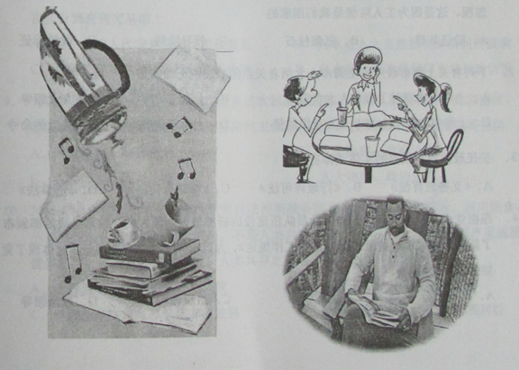
【参考答案】
Dear Sir/ Madam,
Since the Reading Festival is around the corner, I’m writing to recommend a picture which can be used in the brochure to remind the students of the pleasure of reading.
In the picture, three students are sitting at the table, discussing heatedly what they have just read. It seems that they have had a lot of fun through the discussion. Though it is admitted that reading is mostly a personal activity which needs quietness and concentration, as far as I’m concerned, it can also be a sharing experience when the same book is being appreciated. Just imagine that you have read a terrific detective story with fascinating and intricate plots. You are so amazed by the genius of the writer and you can’t help sharing it with your classmates or best friends, who turn out to have been deeply impressed as well. The moment you mention the book, the passion and enthusiasm about the story will explode which can never be gained on your own. My ideal atmosphere of reading is just like that, through which you can not only appreciate the content by yourself, but also have the pleasure of sharing the plots or opinions with your peers, which will ultimately enhance your understanding of the book. To sum up, the reason of my recommendation is quite simple and apparent that reading, instead of being dull and isolating, can be full of participation and common interest. I sincerely hope that you will take my suggestion into consideration and I’m looking forward to your early reply.
Yours sincerely,
Pan Yang
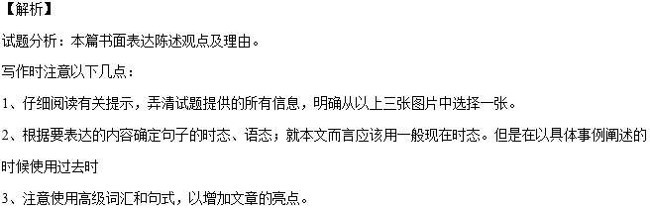
(2015﹒福建)
书面表达(满分25分）
请阅读下面图画，按要求用英语写一篇词数为120左右的短文。
内容包括：
1. 描述画面；
2. 概述其含义；
3. 谈谈个人感想。
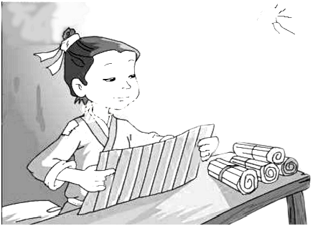
凿壁偷光
注意：
1. 短文开头已给出,不计入总词数；
2. 可以适当增加细节,以使行文连贯；
3. 短文中不能出现与本人相关的信息；
参考词汇：凿，钻：bore
In the picture,
【答案】
In the picture ,we can see a boy in worn clothes,sitting at a shabby wooden table with a pile of books on it.A weak ray of light came in through a small hole in the wall and he was absorbed in his reading.
This is a well-known story from ancient Chinese idiom.The boy, being poor ,couldn’t afford even a candle,so he bored a hole in the wall to “steal” light from his neighbour ‘s house to read at night.The moral of the story is spare no effort to accquire knowledge and never get discouraged easily no matter how difficult the situation may be
Of course, things are totally different today It is not the story itself but what is reflected in the story that counts.Hard work pays off.We should take pains to improve ourselves through learning and get perpared for the future.
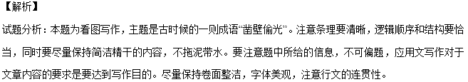
【亮点分析】
文章第一段描述图片，第一句中用到了动词ing形式的非谓语动词做伴随状语和with 的复合结构In the picture ,we can see a boy in worn clothes,sitting at a shabby wooden table with a pile of books on it.图中我们可以看见一个男孩穿着破旧的衣服坐在一个堆满书的桌子旁边。A weak ray of light came in through a small hole in the wall and he was absorbed in his reading.一丝微弱的光亮从墙上的一个小洞穿过，他沉静在自己的阅读中。
第二段第一句开始说这个图片的主题。This is a well-known story from ancient Chinese idiom.这是一个众人周知的中国古代成语。第二句也是用了一个分词结构表示伴随状语The boy, being poor ,couldn’t afford even a candle,so he bored a hole in the wall to “steal” light from his neighbour ‘s house to read at night.这个贫穷的男孩甚至不能够买得起一根蜡烛，于是他把墙凿了一个洞，从他邻居那里偷了一些光在夜晚阅读。第二段最后一句用了一个no matter引导的让步状语从句。The moral of the story is spare no effort to accquire knowledge and never get discouraged easily no matter how difficult the situation may be.故事的精神是要不遗余力的获取知识，并且不管有多么困难的情况从不轻易气馁。
第三段结束Of course, things are totally different today .当然，现在可完全不同了。第二句是一个not… but 结构以及宾语从句It is not the story itself but what is reflected in the story that counts.不是这个故事本身而是这个故事反映出来的东西才是重要的。俗语：Hard work pays off.功夫不负有心人。We should take pains to improve ourselves through learning and get perpared for the future.我们应该带着苦来通过学习来改进自己并且为未来做准备。
注意：词数不少于60.
提示词：一个面团a piece of dough 面人dough figurine
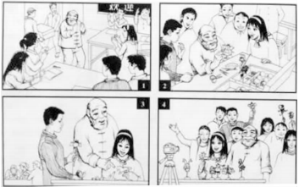
【答案】
Last Tuesday, our class invited an old craftsman to teach us how to make dough figurines.
When the craftsman came into the classroom, we gave him a warm welcome and two boys helped him with the tool box. First, he showed us the basic steps and skills of making dough figurines. We stood around him and watched attentively. Then we started to have a try ourselves. The old man walked around and helped us patiently.
Finally, we put the figurines we made on the table and took pictures with the old craftsman. Looking at the figurines, we were all very excited.
We hope we can have more activities of this kind!
【解析】
试题分析：本文依然用四幅图的形式展现了一个活动的过程，与往年一样，体裁为记叙文。与往年不同的是，命题并未给出作文开头，需学生自己写一个事件的概括及总体感受作为文章的第一段。
(2016﹒北京)第二节（ 20 分）
假设你是红星中学高三一班的学生李华。你班同学参加了学校的“地球日”系列活动。请按照以下四幅图的先后顺序，以“Actions for a Greener Earth”为题，给校刊“英语角”写一篇英文稿件，介绍活动的全过程。
注意：词数不少于60。
提示词：地球日Earth Day

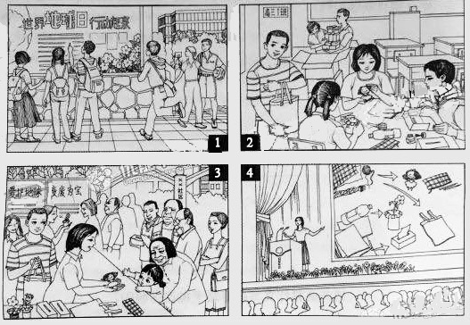
【答案】
Actions for a Greener Earth
A week before Earth Day, posters were put up around our school, calling upon us to join in the actions for a greener earth.
Our class came up with the idea to make better use of used materials. We brought to our classroom worn-out clothes, pieces of cardboard and empty plastic bottles and turned those into dolls, handbags, tissue boxes and small vases. That weekend, we went to a nearby neighborhood and gave them away to the people there. All were very happy with those unexpected gifts, especially little kids and elderly people. We did so well that we were invited to share our idea and experience with all the students of our school.
We are very proud of ourselves and believe we can do more for a better world.
【解析】题目要求按照四幅图的先后顺序，以 “Actions for a Greener Earth”为题，给校刊“英语角”写一篇英文稿件，介绍活动的全过程。词数不少于60词，参考词汇必须使用。使用一般过去时和第一人称进行写作。
(2017﹒江苏)
请认真阅读下面有关我国电影票房收入(boxoffice income)的柱状图及相关文字，并按照要求用英语写一篇150词左右的文章。
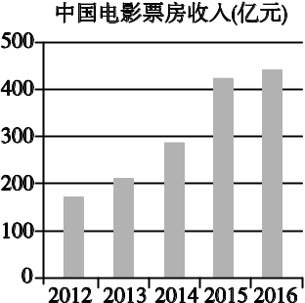
Saturday Afternoon.In a Shopping Centre.
Li Jiang：Hi，Su Hua. Which movie shall we see?
Su Hua：Whatever. We've got so many choices, Kung Fu Yoga, Journey to the West…Each sounds great!
Li Jiang：Yeah！And some movie stars are fantastic.
Su Hua: And the hightech！…
Li Jiang：Perfect！Let's get some food first. We only have 20 minutes left.
Su Hua：No hurry. The cinema is on the same floor.
One Day in 2016.At Home.
Son：Mum，shall we go and see a film tonight?
Mother：Why bother? We can stay at home and watch films online. It's convenient with our new and faster network.
Son：But it feels good in a cinema.
Mother：And the price…We have to pay 50 yuan a ticket.
Son：Only 10 yuan more than last year.
Mother：But still we cannot get the money's worth. Some films are just boring…
【写作内容】
1．用约30个单词概述柱状图信息的主要内容；
2．我国电影票房收入变化的原因有哪些，简要谈谈你的看法(上述对话仅供参考，原因不少于两点)；
3．谈谈你对我国电影票房收入走向的看法，并简要说明理由。
【写作要求】
1．写作过程中不能直接引用原文语句；
2．作文中不能出现真实姓名和学校名称；
3．不必写标题。
【评分标准】
内容完整，语言规范，语篇连贯，词数适当。
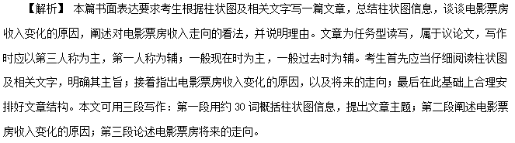在遣词造句上，应当注意合理使用连接成分，以提高文章的逻辑性，如在列举理由时可以用to begin with, what's more, last but not least等；还应尽量使用较复杂的句型，如在总结全文大意时可以用定语从句、分词结构；在其他地方可以用主语从句、倒装句等。
【参考范文】
The boxoffice income of Chinese movies witnessed a constant increase from about 17 billion yuan in 2012 to over 40 billion in 2015. However, that increase slowed down in 2016.
The reasons behind this are various. The fast economic development before 2016 was probably the most powerful engine driving the constant growth in the boxoffice income. The application of new technologies and the wide appeal of movie stars could also account for the increase. However, China saw a decline in its economic growth rate last year. And the Internet increased options for movie lovers. Consequently, some viewers began to turn away from cinemas, leading to a slower growth.
China's economy is expected to grow at a medium speed in the coming years, so an increase is possible in the investment in the movie industry and the number of quality movies. Therefore, its boxoffice income will probably enjoy a slight increase.
(2017﹒北京)
情景作文

假设你是红星中学高三学生李华，请根据以下四幅图的先后顺序，写一篇英文周记，记录毕业前夕你们制作以“感恩母校”为主题的毕业纪念视频的全过程。
注意：词数不少于60。
提示词：视频video
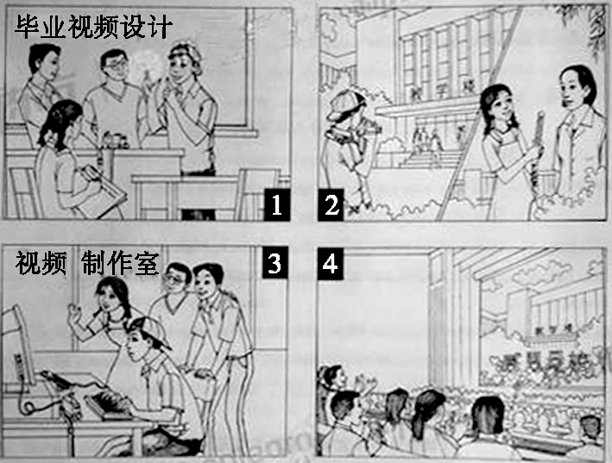
________________________________________________________________________
________________________________________________________________________
参考词汇和句型：
1. In order to leave some impressive memories for all of us before graduation, our class made a special video to express our appreciation to…
2. carried out a discussion/various ideas were put forward
3. shot some wonderful videos in the school/interviewed our teachers…
4. Those who are talented in computer contributed to the making of the video.
5. edited the video/added our love to…
6. The show received a warm welcome among our fellow schoolmates.
7. Memories of the past flooded into our minds/firm bond to our school…
内容要点：
1. 讨论分工 2. 收集素材 3. 编辑制作 4. 放映视频
One possible version：
Graduation finally came. My classmates and I decided to do something. After a heated discussion, we agreed on making a video to record our experiences at school. Material collecting took us a whole week, during which we interviewed our teachers and took pictures of every aspect of school life. The editing part after that was tough. We debated over what to put into the video. Some compromises were unavoidable, but the video turned out perfect. Several days later, when the video was played on the graduation ceremony, it was well received. The students and teachers shared a great time. That surely gave us a great sense of achievement.
(2018﹒北京)
第二节
57. 假设你是红星中学高三学生李华，请根据以下四幅图的先后顺序，写一篇英文周记，记述你们上周接待外国学生，带领他们体验中国茶文化的全过程。
注意：词数不少于60。
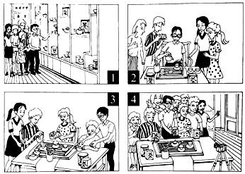
(请务必将作文写在答题卡指定区域内)
【答案】Last week, we took the foreign students in our school to experience the authentic tea culture, which turned out be to extremely rewarding.
On arriving at the tea house, the foreign students were impressed by the unique tea pots and tea cups. I gave them a vivid and informative introduction of tea culture, including its profound history, its rich variety, and the exquisite craftsmanship of making tea with their interest greatly sparked, I then began to teach them how to make tea.
In order to deliver a clear presentation, I slowly explained the traditional procedure of making tea in detail. Absorbed in every move of mine, the foreign students were once again amazed by this unique culture and they couldn’t help taking pictures from time to time.
Next came the moment when I asked them to have a try themselves. Washing the tea pots, adding tea leaves, and pouring water into the cups, they followed my instructions and were really immersed in charming tea culture. The tea house witnessed a really enjoyable time for all of us.
At the end of the activity, holding the tea bags in our hands, we took a picture to memorize the unforgettable day. It suddenly hit me that traditional culture like tea culture was of great charm and huge value. And I swelled with pride to spread our own culture to people all over the world.
【解析】本文为图片介绍类作文，这类作文是根据给出的一幅或几幅图画所提供的信息写短文。此类题的体裁较广泛，可以是记叙文、说明文，也可以是议论文。按照本文的要求可知，是写一篇记叙文。
1. 认真读图，把握中心。
根据提示可知，内容是带领外国学生体验中国茶文化的全过程，介绍了茶具，泡茶，沏茶，品茶的过程，所以这是这组图画所要表达的中心。
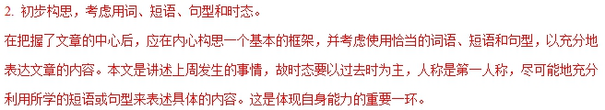 3. 连词成句，然后再连句成文。
运用适当的单词或短语正确表达各图的意思。然后再将各图的单个句子串连起来。
串连时，要注意使用适当的连接词语或过渡性语句，不至于让读者觉得文章中出现跳跃现象，更使上下文更为紧凑、自然。
4. 反复审核，修改错误。
一篇文章写好后，应进行检查，看短文中是否有错，如拼写、用词、时态、语态及表达方面的错误。
5. 宜详则详，该略则略。
对于一些细节方面的内容，如果是文章必不可少的，在写作过程中是不可将其忽略的。
如果是可有可无的细节，则可视具体情况进行增删。据此，我们在读图时一定要注意阅读各图中的一些细节内容，看其是否影响文章的内容。
亮点说明：
巧妙使用定语从句，提升了文章档次：Last week, we took the foreign students in our school to experience the authentic tea culture, which turned out be to extremely rewarding.
使用非谓语动词，使句子表达更简洁：
On arriving at the tea house…
I gave them a vivid and informative introduction of tea culture, including its profound history, its rich variety,
Absorbed in every move of mine, the foreign students were once again amazed by this unique culture
holding the tea bags in our hands, we took a picture to memorize the unforgettable day.
使用倒装句突出重点。
Next came the moment when I asked them to have a try themselves.
使用it做形式主语，使表达更地道。
It suddenly hit me that traditional culture like tea culture was of great charm and huge value.
(2019﹒北京)
第二节(20分)
52.假设你是红星中学高三学生李华。你们班上周组织了一次以“劳动最光荣”为主题社会实践活动。请根据以下四幅图的先后顺序，写一篇英文周记，记述整个过程。
注意：词数不少于60。
提示词：西瓜watermelon
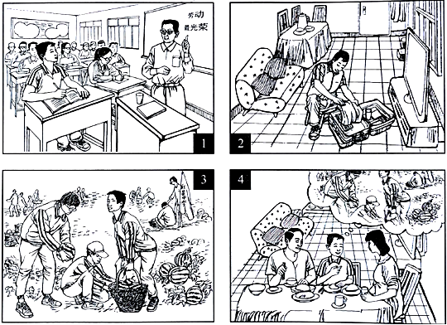
____________________________________________________________________________________________________________________________________________________________________________________________________________________________________________________________________________________________________________________________________________________________________________________________________________________________________________________________________________【答案】
Last week I took part in a farmwork programme in the suburbs.
At the class meeting, our teacher told us about the programme with the theme “Working is most beautiful”. And he stressed the importance of working with our own hands. When I got home, I packed up my luggage for the trip.
On the farm, we helped pick watermelons. While working, I realised how hard it was to work in the fields under a hot sun.
When I came back home, I shared my experiences with my parents. And they were very proud of me.
【写作指导】
本文属于图画作文，要求根据图画内容写一篇英文周记。
【详解】假如你是红星中学高三学生李华，你们班上周组织了一次以“劳动最光荣”为主题的社会实践活动。要求根据以下四幅图的先后顺序，写一篇英文周记，记述整个过程。图画作文内容要点比较清晰，其中包括：老师宣布活动内容和意义，我为活动准备，在农场的劳动过程，介绍活动感受。这样有利于学生写作时发挥与扩展。全文可分成三部分，开头段概括活动，中间段描述图画，结尾段总结收获和意义。文章用第一人称来写，使用一般过去时。
【点睛】本文内容完整，语言表述通顺。使用了连接词、衔接词，使文章自然、流畅。文章使用了宾语从句 how hard it was to work in the fields under a hot sun.还使用了 At the class meeting, When I got home, On the farm, While working, When I came back home等过渡词。
(2019﹒天津)
假设你是晨光中学的李津，英国友好校将派教师来你校参加为期一周的暑期交流活动。活动期间，英方教师Chris 将做一个有关西方艺术的讲座、现就讲座内容征求你校学生的意见。请根据以下提示给Chris写一封电子邮件:
（1）你喜欢的讲座话题（从音乐、美术、舞蹈中任选其一）；
（2）选择该话题的原因及关于该话题你感兴趣的内容；
（3）希望从中有何收获。
注意：
（1）词数不少于100：
（2）可适当加入细节，使内容充实、行文连贯；
（3）开头和结尾已给出、不计入总词数。
Dear Chris，
I'm Li Jim，a student at Chenguang High School.
____________________________________________________________________________________________________________________________________________________________________________________________________________________________________________________________________________________________________________________________________________________________________________________________________________________________________________________________________________
Thank you for your time.
Yours，
Li Jin
【写作指导】
这是一篇提纲类作文，我们需要用正确的英语把给出的要点表达出来。动笔前，一定要认真分析要点，理解要点要表达的含义，不能遗漏要点，跑题偏题。本作文中给出的要点比较具体，故需要准确表达。写作时注意准确运用时态，上下文意思连贯，符合逻辑关系，尽量使用自己熟悉的单词句式，同时也要注意使用高级词汇和高级句型使文章显得更有档次。特别注意在选择句式时要赋予变化。平时除了加强词汇积累，写作联系以外，还可以适当记忆一些类似的范文，这样在考试中可以起到事半功倍的效果.
【范文】
Dear Chris，
I'm Li Jin, a student at Chenguang High School. I got the news that your school will send teachers to my school for a week-long summer exchange. During the activity，you will give a lecture on Western art. You want to seek for advice on what topic the lecture will be about. From my personal note，music is my priority.
I am interested in all kinds of music，among which Jazz is my favorite. I want to know about the history of jazz，and some famous jazz singers. I would appreciate it if you can add some sessions of enjoying jazz.
Thank you for your time.
Yours，
Li Jin

